**Node Failure in MANET**

**Software Used:** NetSim Standard v10.1 (32-bit), Visual Studio 2015

Nodes in a network can fail due to a variety of reasons e.g., broken node hardware, a broken network, software bugs etc. First Node failure and half node failure time will have direct impact on the Network lifetime. To analyse the reliability of a MANET network we can fail nodes at a specific time and analyse its impact over the Network Performance.

We use an input file NodeFailure.txt which contains the Node Id’s and the respective time (in micro seconds) at which they will fail.

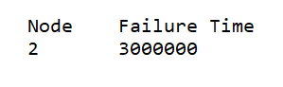

# Steps to run Node Failure Code in NetSim:

1. Open the Simulation - Node Failure folder and double click on the NetSim.sln file from Code folder to open the project in visual studio 2015.
2. Right click on the DSR project in the solution explorer and select Rebuild.

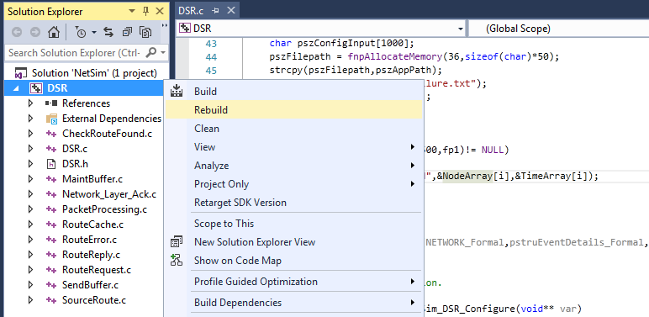

1. Now copy the newly built libDSR.dll file from the DLL folder that is inside the Code folder.

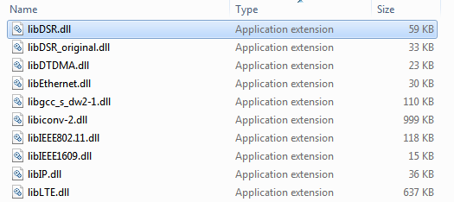

1. Replace the newly built dll in the bin folder inside the NetSim installation directory (C:\Prgram Files (x86)\NetSim Standard\bin), after renaming the original libDSR.dll file.
2. Create a network scenario in MANET and configure traffic.

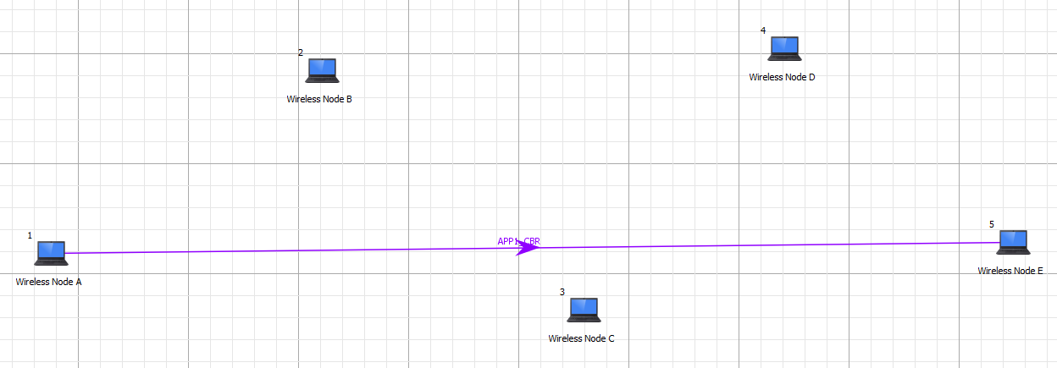

1. Create a text file named NodeFailure.txt containing the details of the nodes you want to fail and the respective time. In this project we set Node 2 as a failure node.
2. Create a scenario in MANET and set Network Layer Routing protocol as DSR.
3. Set the Progpagation Model as followed

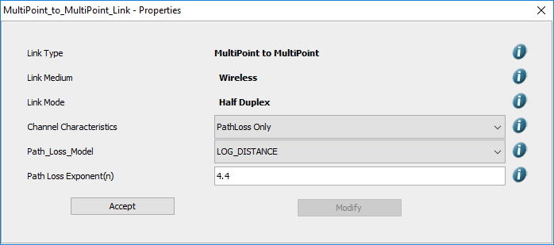

1. Run the Simulation.
2. View packet animation. You will note that once a node fails it stops forwarding packets it receives.
3. In performance metrics window user can see the variation in throughtput. Using default libDSR.dll the throughtput value is 0.2350 mbps but using the modified node failure libDSR.dll it will be 0.0482 mbps.